**Chapter 2 Related Work**

With the development of AI approaches, there are several mature application or API for voice recognition and nature language processing. This chapter will introduce relative studies on voice recognition, state-of-the-art of NLP, and current status for AI-based EHR in healthcare industry.

**2.1 Voice Recognition Methods**

Google voice recognition API [10], Iflytek voice recognition API [14] and Baidu voice recognition API [11] are the main products that provide Chinese language recognition service. All these APIs will be test in this project to figure out the accuracy of each API and find the best one.

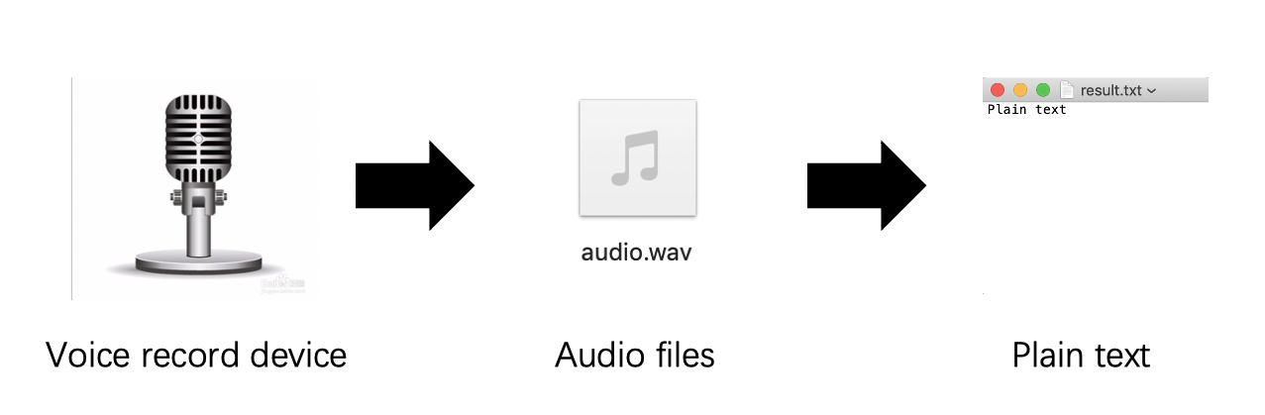

Figure 2.1: Voice Recognition Workflow

**2.1.1 Baidu Voice Recognition**

Baidu voice recognition API supports the self-training model on the voice self-training platform, and the training can be completed with zero code after uploading the vocabulary text in a dictionary. It can accurately improve the vocabulary recognition rate of the specific domain by 5-20%. To use Baidu voice recognition API, an access key should be applied. [11].

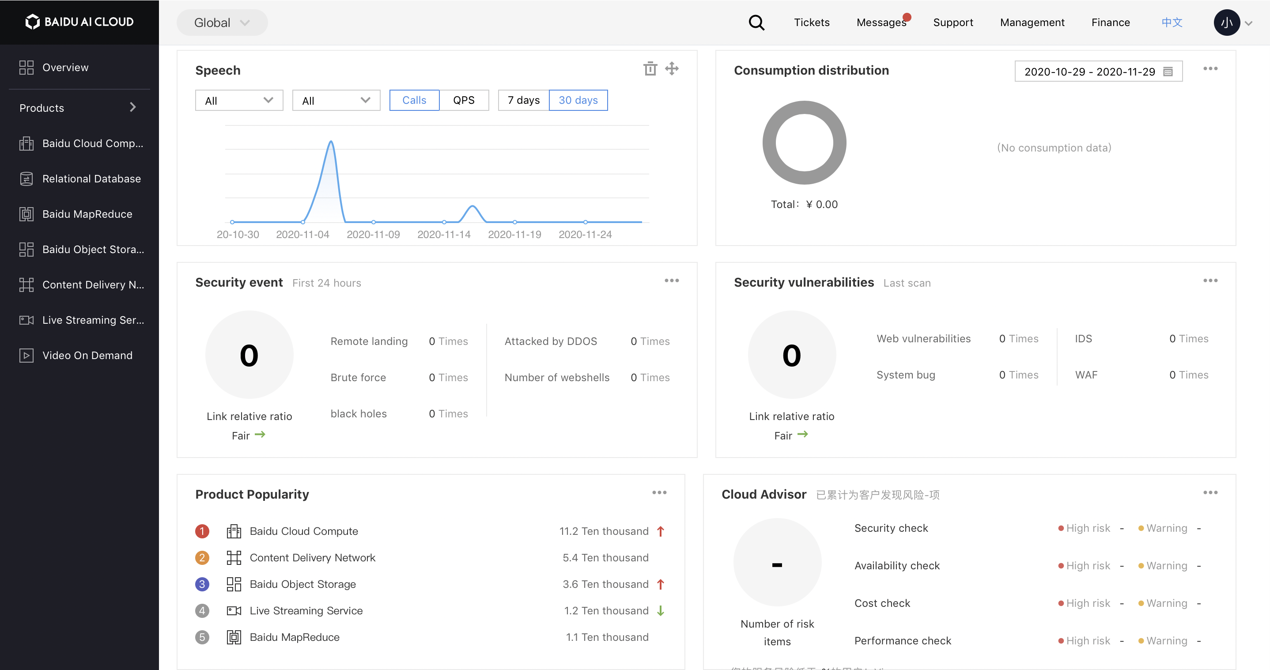

Figure 2.2: Baidu AI server Main Page

**2.1.2 Google Voice Recognition**

Google with voice recognition API supports voice recognition that supports more than 125 languages and variants for free and without the restriction of access key. The same as Baidu voice recognition API, it can customize speech recognition to transcribe domain- specific terms and rare words and boost your transcription accuracy of specific words or phrases. In addition, it can automatically convert spoken numbers into addresses, years, currencies, and more using classes.

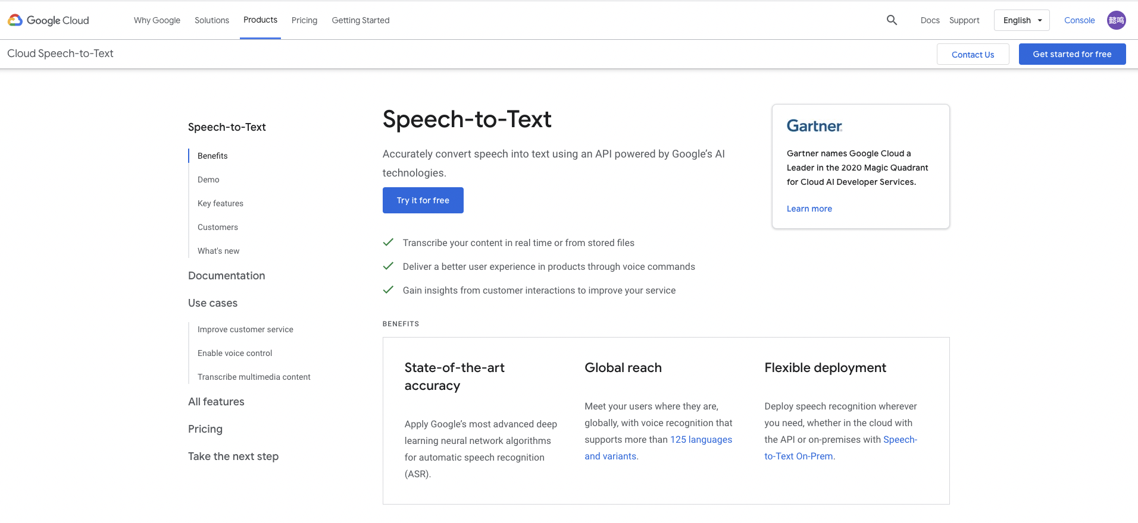

Figure 2.3: Google AI server Main Page

**2.2 Nature Language Processing methods**

According to a literature review [15], an NLP system includes two parts: syntactic processing modules and semantic processing modules. Several different NLP systems based on English have been utilized to extract key information from clinical contents, such as MedLEE, MetaMap, KnowledgeMap, cTAKES, HiTEX and MedTagger [15]. 65% of existing NLP systems use rule-based methodology while the rest use machine learning based methodology to do the information extraction. The table below listed five frameworks or tools on clinical information extraction, which are the most mentioned in publications from 2009 to 2016.

Table 2.1

Top 5 information extraction frameworks/tools included in publications from 2009-16.

page14image7275264

page14image7289088page14image7289280

There are many English language processing frameworks and tools such as NLTK, Stanfordnlp, and CoreNLP. However, similar tools based on Chinese language are relatively too little to find any research on utilizing these tools on EHR. Chinese sentence syntax and word characteristic components are quite different from English grammar, so a Chinese language processing tool are required in this project.

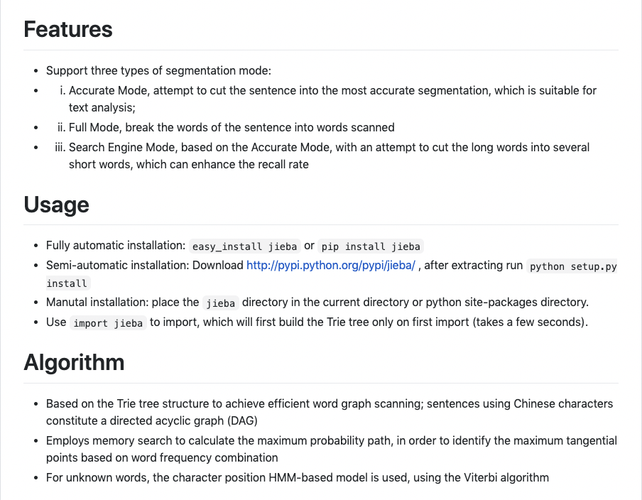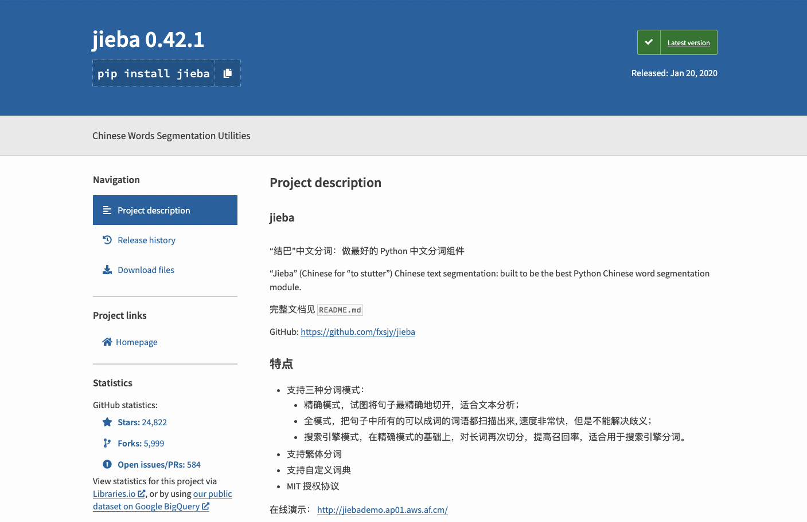

Figure 2.4: Jieba Main Page.

Figure 2.5: Features and Usage Docu- mentation for Jieba.

”Jieba” (Chinese for ”to stutter”) [16] is one of Chinese text segmentation tools, which is built to be the best Python Chinese word segmentation module. It implemented almost all the functions similar to other English language processing frameworks and tools. Keyword Extraction, Part of Speech Tagging, Tokenize are the main functions which used in this project.

**2.3 Overview of Voice Assistant for EHR**

Several voice recognition and language processing systems had been developed which only supported English. Alexa voice assistant of Amazon [17], Saykara [18] and Suki [19] are famous and mature applications of AI assistant for doctors on either mobile platform or computer platform. Unfortunately, there has been no similar research or application in Chinese hospitals and clinics except IFLYTEK CO.LTD. [14] started implementing a voice EHR system in 2017.

**2.3.1 Iflytek EHR**

System of Iflytek [14] is designed to synchronously records the voice into patients’ medi- cal record, when doctors communicate with the patient. This project will explore feasible approach and method to implement voice recognition technology as well as NLP on auto- matically filling keywords into EHR to improve the efficiency of doctor’s diagnose based on Chinese.

Figure 2.6: Iflytek Main Page

However, there is only description of such system on the Chinese official website of Iflytek and even not mentioned on English version of website. In this case, this project regards it as an unfinished system, which is still under development. Refer to this hypothesis, there does not exist any of developed AI-based EHR systems in China.

